18. Plot of a R%-G% Diagram
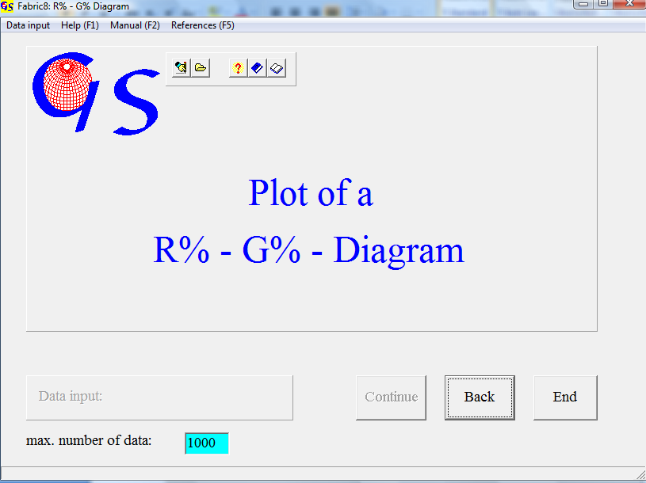
Fig. 1

This program (Fig. 1) plots the degree of preferred orientation (R%) against the cylindricity (G%) of a spherical distribution. The degree of preferred orientation is defined as:

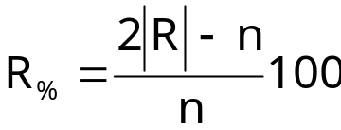
|R| = magnitude of the vector sum, n = number of data

The cylindricity is
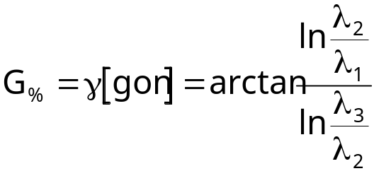
λ₁<λ₂<λ₃ are the eigenvectors of the orientation tensor (See Prog. 8).

Fig. 2 shows the form for manual input. Degree of preferred orientation and cylindricity are written in the fields. Each pair of data is represented by a symbol which must be chosen from the field “Symbol”.

Input from a file is similar as in all other programs. The extension of a data file is ‘.RGD‘.

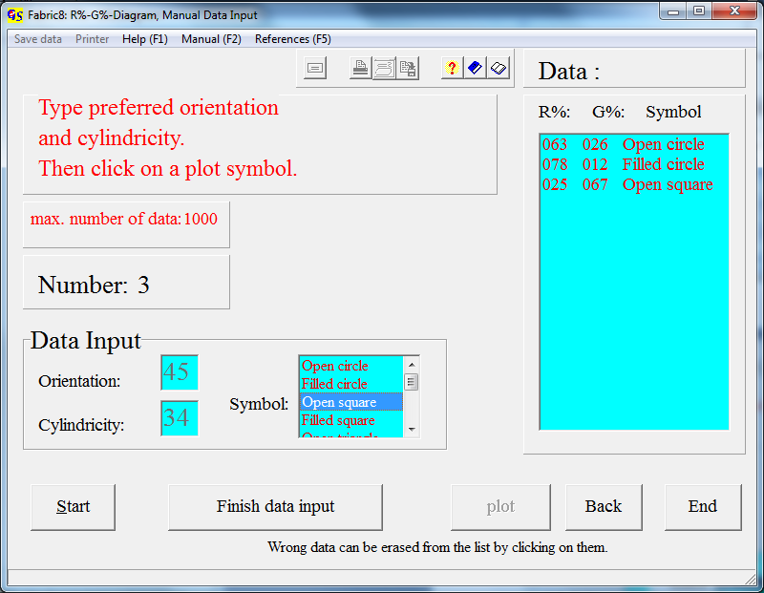
Fig. 2

Fig. 3 shows the graphic form.

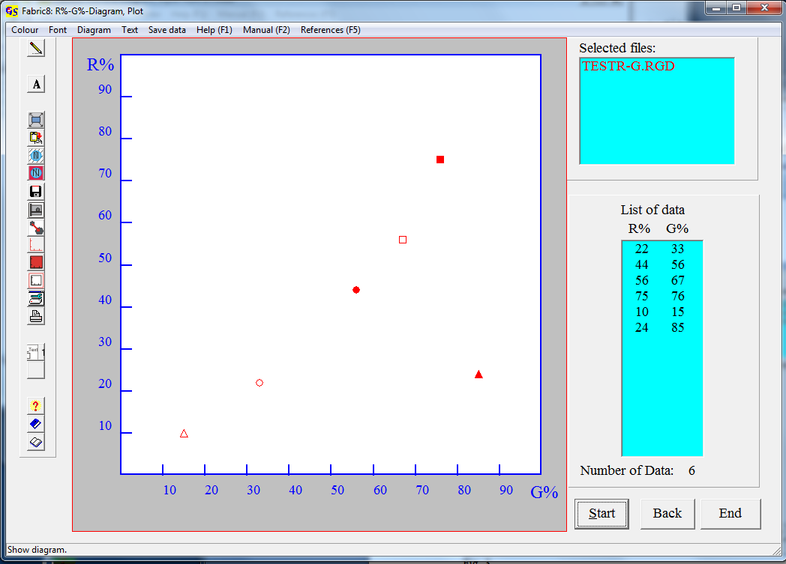
Fig. 3

The menus “Diagram“, “Text“, and “Save data” are explained in Programm 3.

